Instruction of Image Selling Setup

System requirements

1) This software build in yii2 framework using adminLte theme for and Restfull api.

2) Need linux based Apache server to host apis.

3) Minimum php 7.3 version required.

4) Mysql database

Database and Email setting

1. Create database on server.  
   Go to your server cpanel and create database from mysql database wizard.  
     
   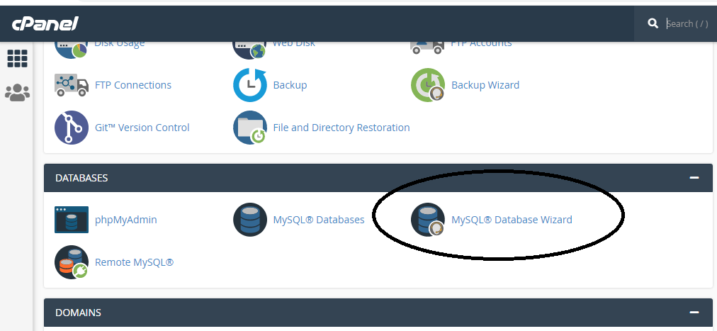
2. Import Mysql database file into your database.  
   database file can be find in doc/db folder.  
     
   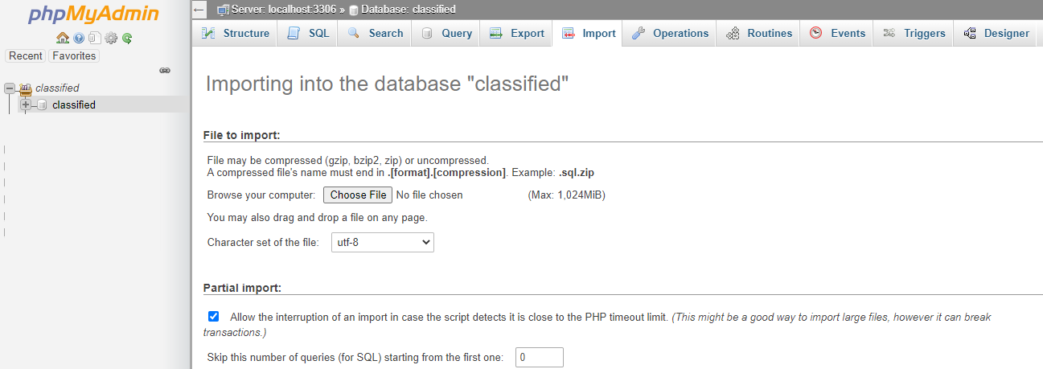
3. Db and email configuration can be updated in common/config/main-local.php. (see below screen shot)  
     
   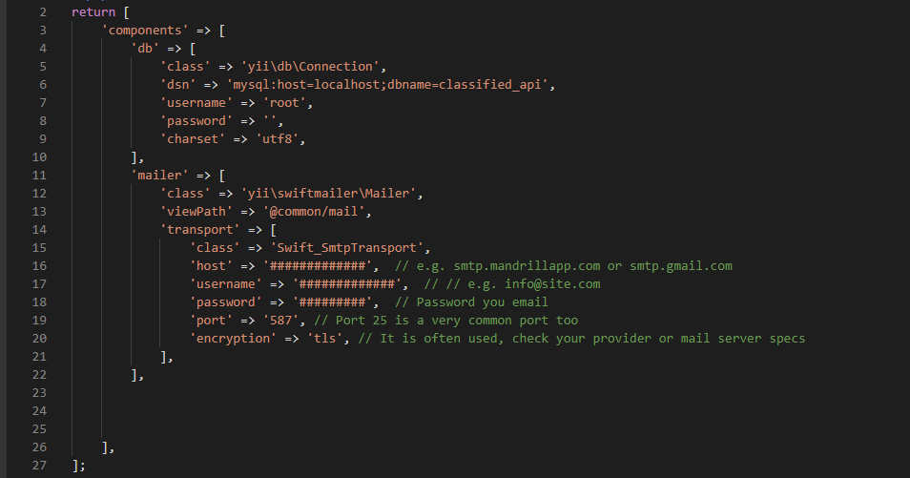

Site URL   
site url can be update from common/config/bootstrap.php

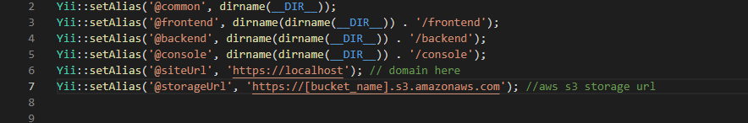

Amazone S3 Setup   
We are using amazone s3 for storage files and images.

* Create Bucket  
  You can create bucket on s3 to follow this URL:  
  <https://docs.aws.amazon.com/quickstarts/latest/s3backup/step-1-create-bucket.html>

After create bucket. You have to create three folder :  
competition

image

user

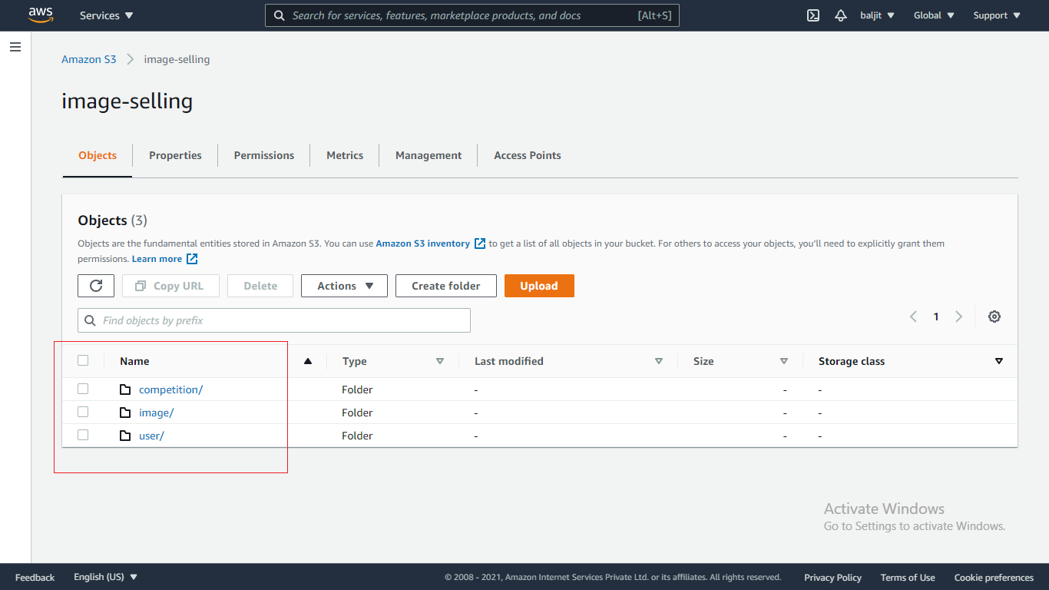

* Amazone S3 Storage URL   
  You can update your aws s3 storageUrl on common/config/bootstrap.php  
  [bucket_name] replace with your bucket name on aws s3  
  suppose sell-image is bucket name on aws then storageUrl will be :  
    
  https://sell-image.s3.amazonaws.com



* Create AWS S3 Access key and secret access key  
  Use following url to create secret keys:  
    
  <https://docs.aws.amazon.com/powershell/latest/userguide/pstools-appendix-sign-up.html#get-access-keys>

After generate the keys, update it with bucket name on common/config/main.php  
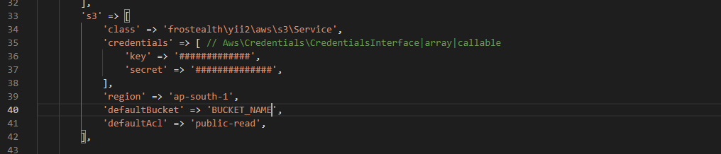

Upload files on server

Once you done above changes then upload all the files on you root folder.

API

1. Used Restfull API
2. All the API response will be in JSON format.
3. API end point url is : youdomin.com/api/web/v1/API_NAME
4. e.g Getting countries list from api : youdomin.com/api/web/v1/countries

Admin Panel

1. Admin Url : youdomin.com/backend/web/index.php
2. Login information :   
   Username : admin  
   Password : 123456  
     
   
3. Dashborad:  
     
   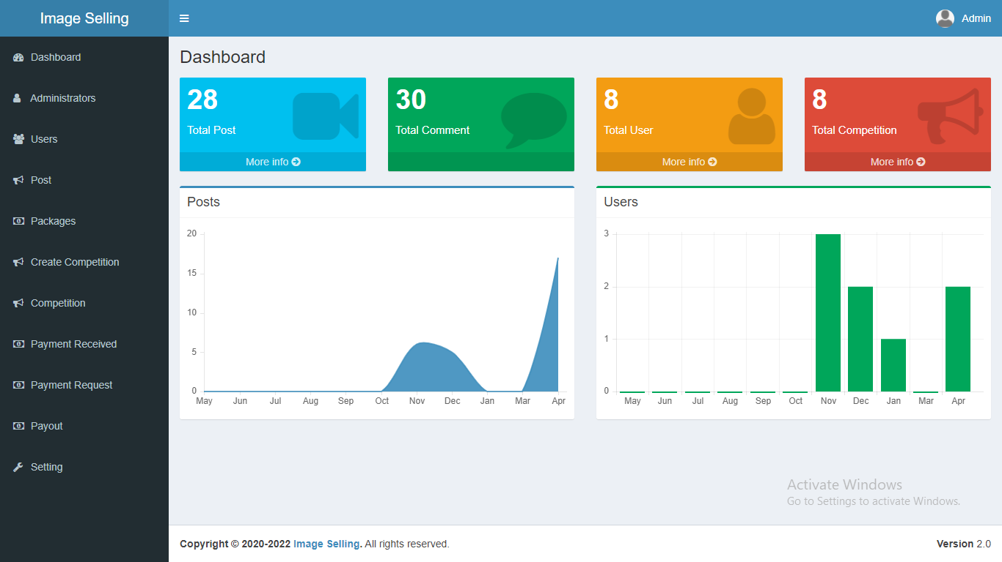

1. Manage User :   
   You can manage and view user detail.  
     
   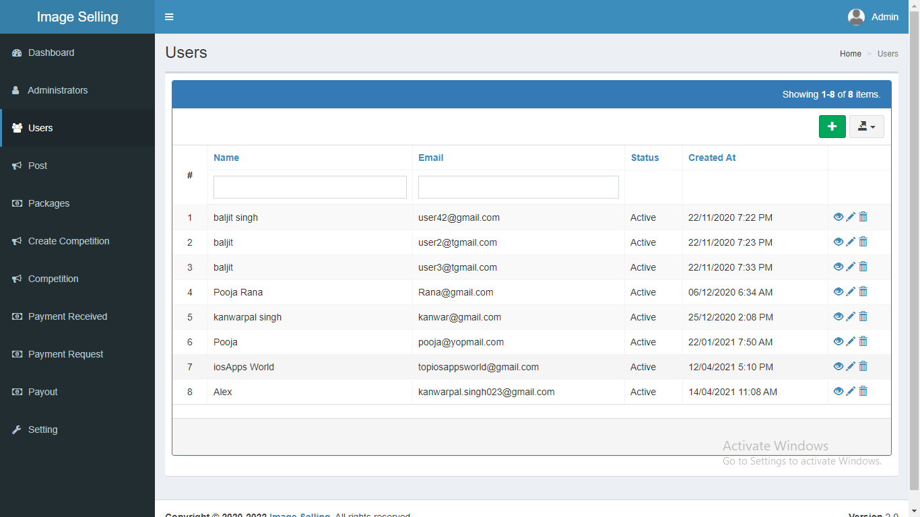
2. Package  
     
   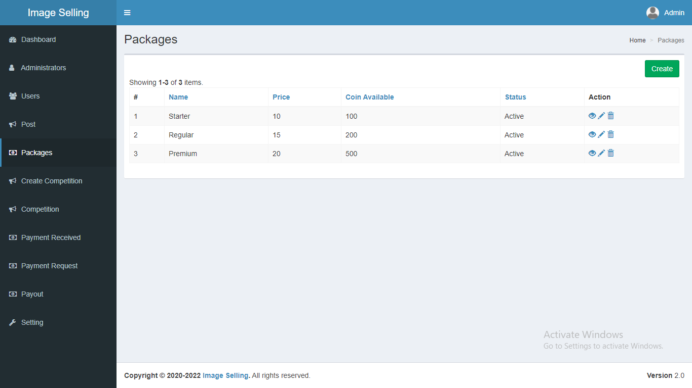
3. Received Payments  
     
   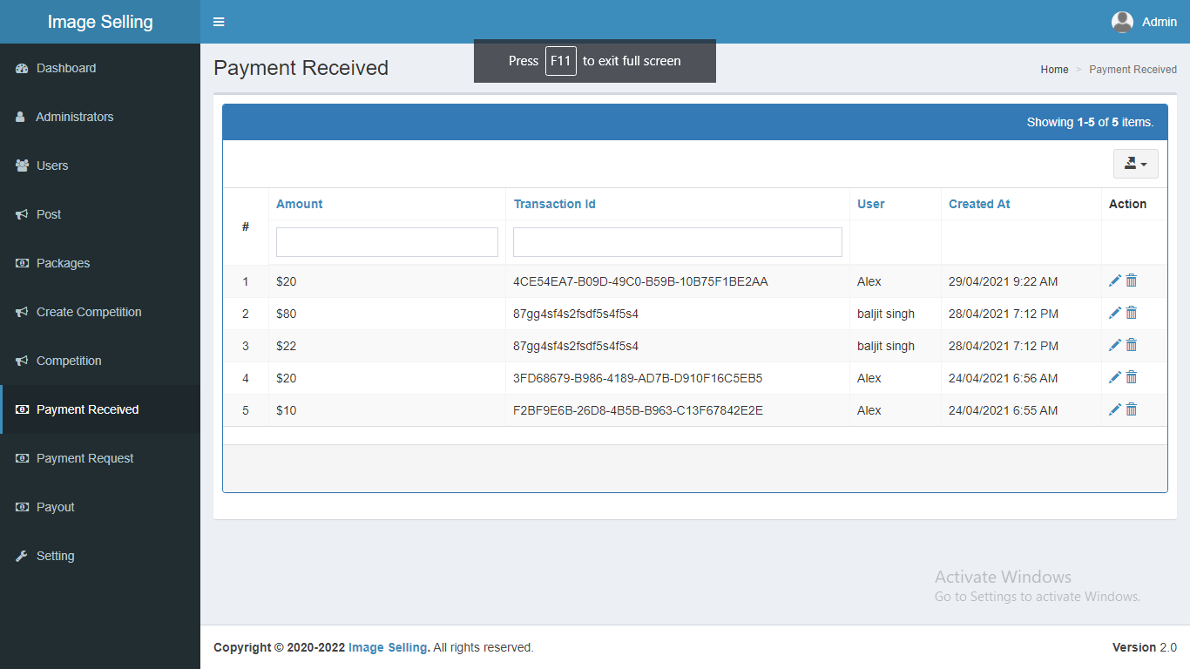
4. Withdraw payment request  
     
   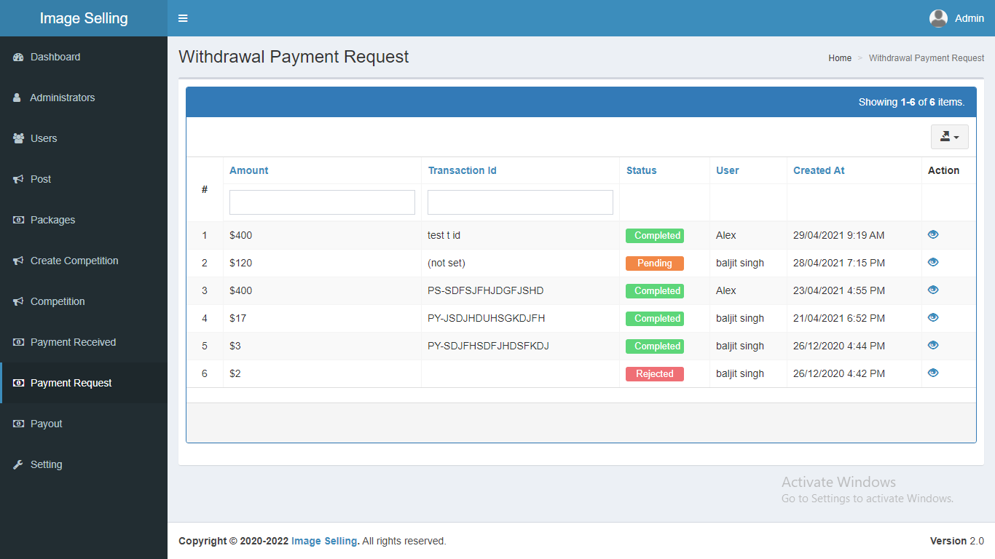
5. Payment Payouts  
     
   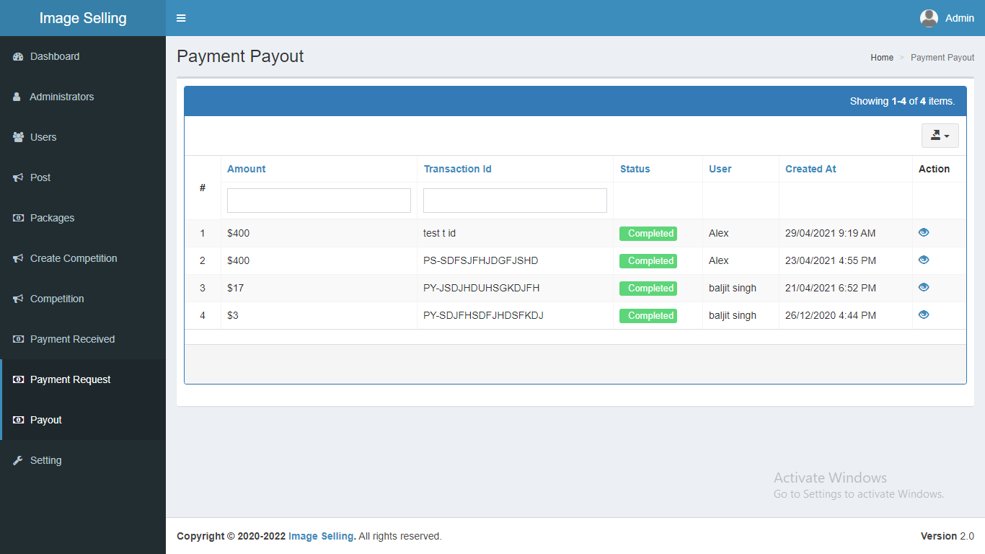
6. Manage Competition  
     
   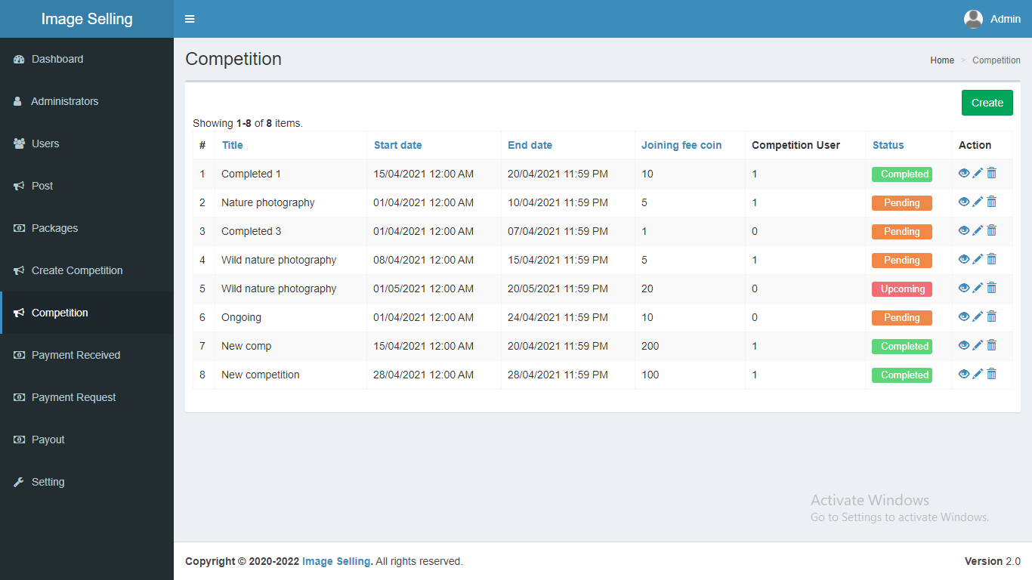  
     
   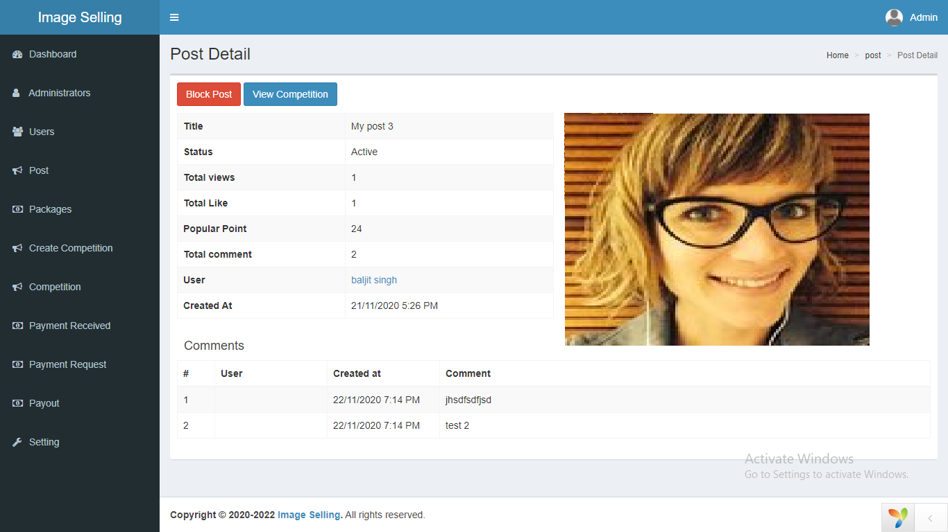  
     
   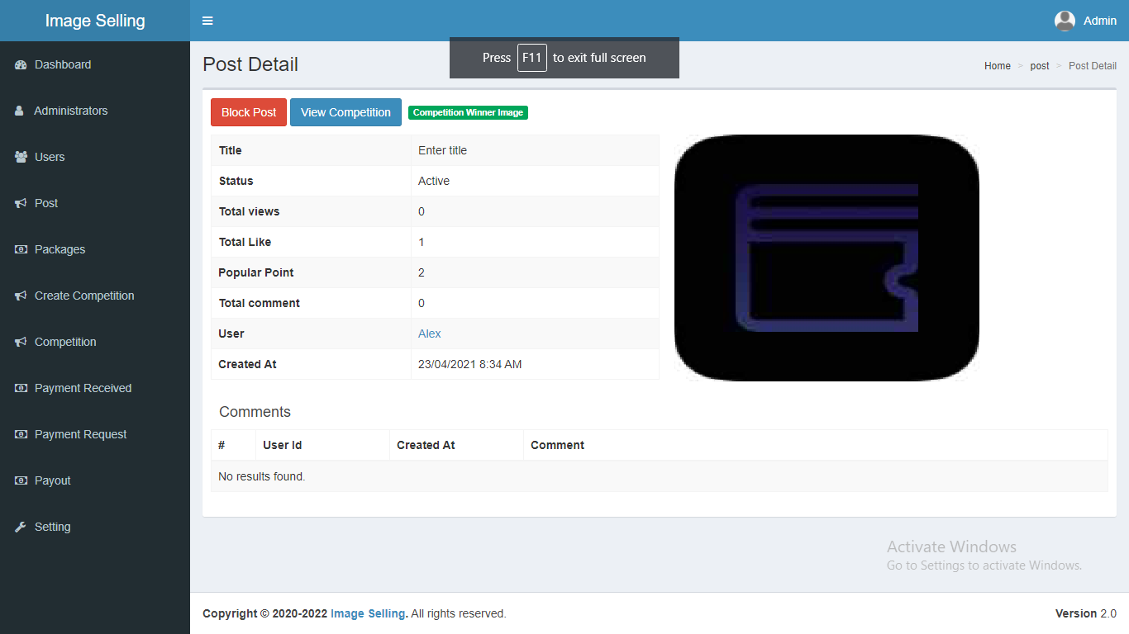  
     
   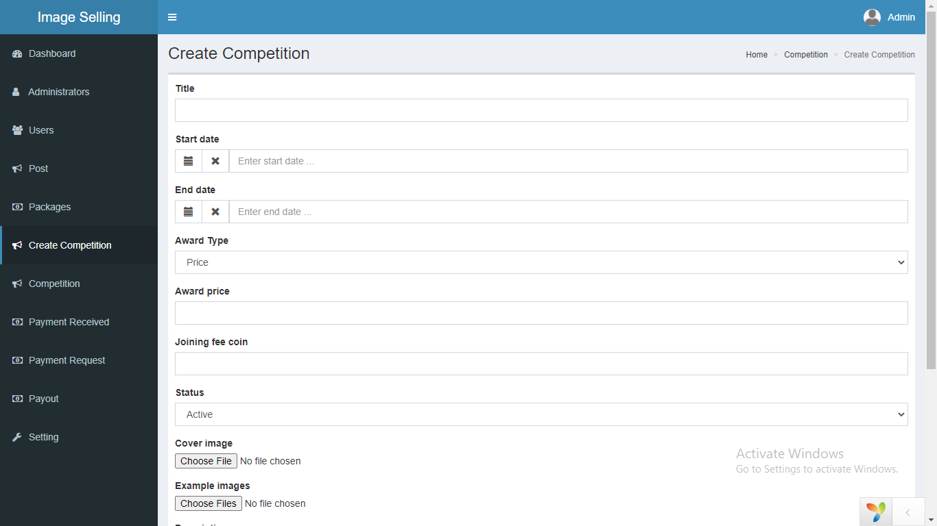  
   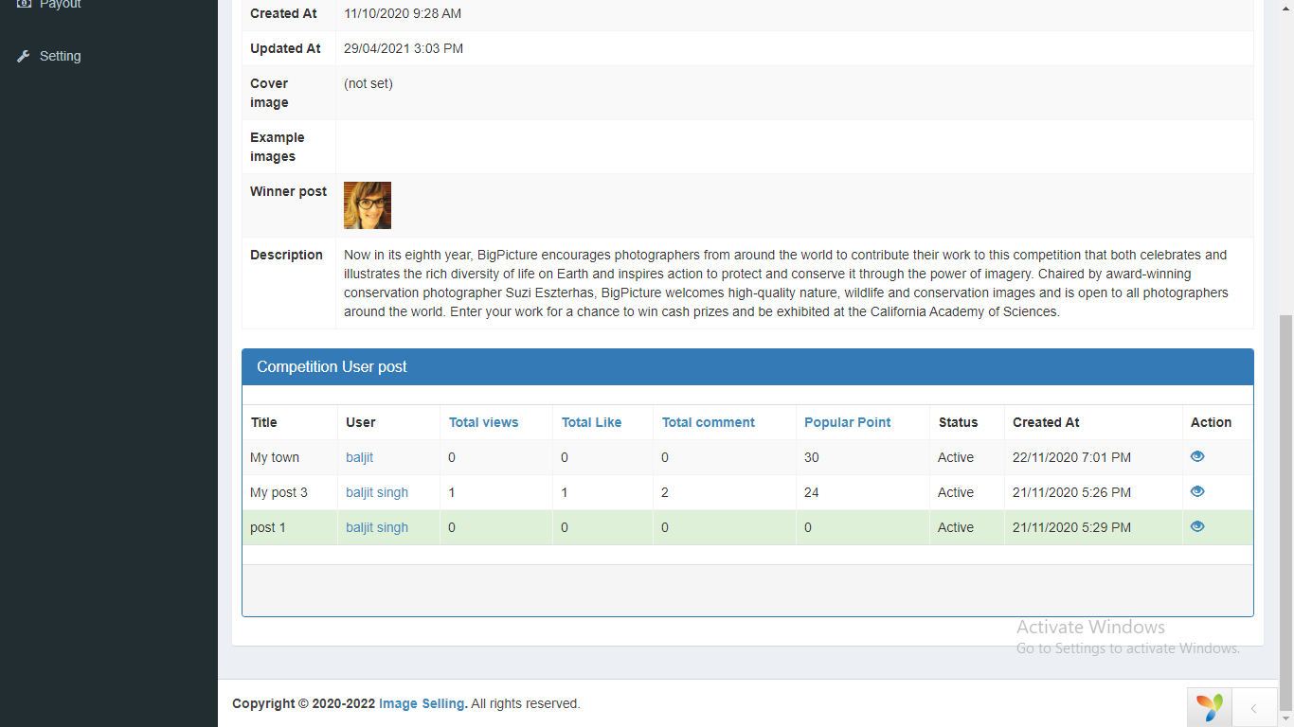

1. Setting  
     
   